|  | **OIL/GAS EXPLORATION AND PRODUCTION – PHASE 2**      ORANGE HOMEWORK TEAM 8  Karthick Krishna Balaji  Camille Carter  Margeaux Johnson  Dillard McMichael  Nish Torane    February 21, 2023 |
| --- | --- |

**Table of Contents**

**Overview** **1**

**Methodology and Analysis** **1**

**Data Used** **1**

**Dry Well Estimation** **1**

**Net Present Value** **1**

**Initial Costs** **1**

**Net Revenue** **2**

**Variable Costs** **2**

**Final Net Present Value** **2**

**Results and Recommendations** **2**

**Dry Well Estimation** **2**

**Wet Well Net Present Value** **2**

**Recommendations** **3**

**Conclusion** **3**

**Appendix** **4**

**Oil/Gas Exploration and Production – Phase 2**

# **Overview**

Compagnie Pétrolière et Gazière (hereafter the “Company”) has tasked Orange Homework Team 8 (hereafter the “Analysts”) to simulate the total cost of a single dry well and the Net Present Value (NPV) of a single wet well. The Company has provided two datasets containing historical drilling costs from 1960 to 2007 and projected costs from 2023 to 2050.

After obtaining the 2023 drilling cost distribution in Phase 1 of the project, the Analysts proceeded to estimate the total cost of a dry well by simulating the leasing, seismic, labor, and drilling costs, each of which came from independent distributions. The resulting distribution had a median expected cost for a single dry well of $5,274,242.

The Analysts also estimated the NPV of a wet well by summing the drilling and completion costs and net revenues from production, discounted by the weighted average cost of capital (WACC). The production rates were simulated using a lognormal distribution for initial production (IP) rates and a uniform distribution for decline rates, with a correlation coefficient of 0.64. The revenue risk was modeled using forecasted oil prices and net revenue interest (NRI), which followed a normal distribution. Finally, the operating costs were modeled using a normal distribution, and a fixed state severance tax of 4.6% was applied after the NRI. The resulting NPV distribution had a median expected NPV for a single wet well of $13,815,193.

# **Methodology and Analysis**

## Data Used

The Company provided the Analysts with two datasets. The first contains historical drilling cost data from 1960 to 2007. This dataset includes the cost in thousands of dollars of drilling crude oil, natural gas, and dry wells. It also provided arithmetic returns for each year and each drilling method. As suggested by the Company, the Analysts only used data between 1990 and 2006. The Analysts converted the character variables to numeric and calculated the average annual cost and return as two new variables. The second dataset contains the projected minimum, maximum, and AEO2021 reference prices of drilling costs from 2023 to 2050 from the World Bank of EIA.

## Dry Well Estimation

The Analysts simulated 10,000 future values to estimate the cost of a single dry well. Producing a dry well includes leasing, seismic, labor, and drilling costs. Leasing costs follow a normal distribution with a mean of 600 acres and a standard deviation of 50 acres, priced at $960 an acre. Similarly, seismic costs follow a normal distribution with a mean of 3 sections and a standard deviation of 0.35 sections, priced at $43,000 per section. Labor costs were, on average, $215,000, with a minimum of $172,000 and a maximum of $279,000. Given this information, the Analysts used two normal distributions to estimate leasing and seismic costs and a triangular distribution to estimate labor costs. Drilling costs were simulated using the normal distribution method from Phase 1.

## Net Present Value

The Analysts also simulated 10,000 future values to estimate the NPV of a single wet well. This valuation requires information about initial costs (seismic and lease costs), net revenues, and variable costs (labor, drilling, and operating costs).

### Initial Costs

Initial costs were calculated similarly to the dry well estimation but included completion costs. Completion costs follow a normal distribution with a mean of $390,000 and a standard deviation of $50,000. The Analysts used three normal distributions to estimate leasing, seismic, and completion costs. Drilling costs were simulated using the normal distribution method from Phase 1.

### Net Revenue

To calculate net revenue, the Analysts simulated the annual production of an individual well. Previous research found that the IP rate follows a lognormal distribution with a mean of 420 barrels of oil per day (BOPD) and a standard deviation of 120 BOPD. The subsequent decline rate follows a uniform distribution bounded between 15% and 32%. The IP and decline rates have a correlation coefficient of 0.64. The Analysts simulated 10,000 IP and decline rates from the respective distributions and correlated the data using the Cholesky decomposition. The results were used to calculate the projected volume of oil produced for the next 15 years. The future yearly projections were simulated with a triangular distribution using the minimum, maximum, and AEO2021 Average Reference and multiplied by the annual oil production.

Before the Company can calculate revenue, it must pay severance taxes to the state and NRI to mineral interest holders. Severance taxes are set at a constant value of 4.6% of revenue. NRI was assumed to be normally distributed, with a mean of 75% and a standard deviation of 2%. The Analysts used a normal distribution to simulate NRI and deducted the fee and severance tax from the total revenue.

### Variable Costs

Additionally, recurring annual fees, including labor and operating costs, must be considered. Labor costs follow a triangular distribution with an average of $215,000, a minimum of $172,000, and a maximum of $279,000. Operating costs follow a normal distribution with a mean of $2.25 and a standard deviation of $0.30. The Analysts used a triangular distribution to simulate labor costs and a normal distribution to simulate operating costs.

### Final Net Present Value

Lastly, the Analysts subtracted variable costs from the final revenue to compute the final net revenue for each year, discounted at the WACC of 10% and summed across each year. The initial cost was subtracted from the final net revenue to compute the NPV forecast. The Analysts repeated this process 10,000 times to create a distribution of expected NPV.

# **Results and Recommendations**

## Dry Well Estimation

Using two normal distributions to estimate leasing and seismic costs, the triangular distribution to estimate labor costs, and estimations for drilling costs from Phase 1, the Analysts simulated 10,000 future values to estimate the cost of a single dry well. **Figure 1** in Appendix shows the simulated values. The simulated values had a 1st percentile single dry well cost of $3,043,400, a median of $5,274,242, and a 99th percentile of $9,175,666. Based on this, the Company can expect costs to exceed $9,175,666 or fall below $3,043,400 only 2% of the time. These values, along with the 25th and 75th percentiles and mean, are recorded below in **Table 1**.

**Table 1: Summary Statistics for Simulated Dry Well and Wet Well NPV**

|  | **1st Percentile** | **25th Percentile** | **Median** | **Mean** | **75th Percentile** | **99th Percentile** |
| --- | --- | --- | --- | --- | --- | --- |
| **Dry Well** | $3,043,400 | $4,478,047 | $5,274,242 | $5,411,996 | $6,175,156 | $9,175,666 |
| **Wet Well NPV** | $3,595,839 | $10,370,276 | $13,815,193 | $14,163,100 | $17,568,719 | $28,203,623 |

## 

## Wet Well Net Present Value

Using information about initial costs (seismic and lease costs), net revenues, and variable costs (labor, drilling, and operating costs), the Analysts simulated 10,000 future values to estimate the NPV of a wet well. The distribution of these simulated values is pictured in **Figure 2** in Appendix. The simulated values had a 1st percentile NPV of $3,595,839, a median of $13,815,193, and a 99th percentile of $28,203,623. Based on this, the Company can expect costs to exceed $28,203,623 or fall below $3,595,839 only 2% of the time. These values, along with the 25th and 75th percentiles and mean, are recorded above in **Table 1**.

## Recommendations

The Analysts recommend that the Company provide historical data regarding the proportion of dry wells to wet wells drilled to better understand the probability of drilling oil. Knowing the risk of potentially drilling a dry well will allow the Analysts to ensure the profits of wet wells outweigh dry wells and other costs.

In addition, the Analysts recommend that the Company utilize the simulated values for wet and dry wells to better anticipate future costs and values. Understanding the possible outcomes will allow the Company to make more informed decisions regarding future drilling projects.

# **Conclusion**

This report details the process of simulating drilling costs for a single dry well and NPV for a single wet well. The Analysts used historical cost data and projected future oil price information to simulate these two distributions. The dry well simulation included leasing, seismic, labor, and drilling costs, each coming from independent distributions. The resulting dry well distribution had a median expected cost for a single well of $5,274,242. The wet well NPV simulation included information on initial costs, net revenue, and variable costs, which necessitated independent distributions. The final wet well NPV distribution had a median expected value for a single well of $13,815,193.

The Analysts suggest utilizing these simulated values to better account for risk and resource allocation. Additionally, gathering information on the probability of drilling a wet or dry well will allow the Analysts to create a plan for the Company to ensure the profits of wet wells outweigh any other costs.

# 

# **Appendix**

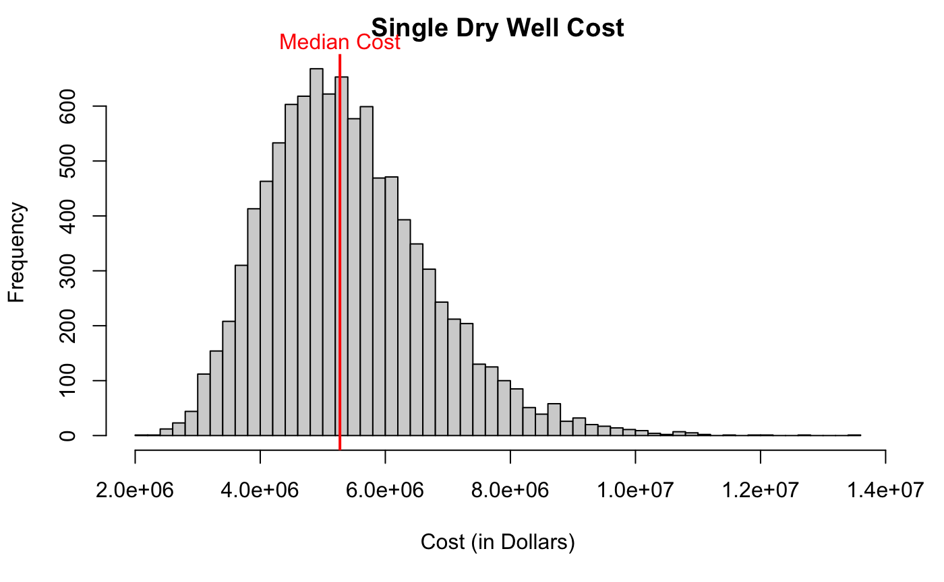

**Figure 1: 10,000 Simulated Future Values of Single Dry Well Cost**

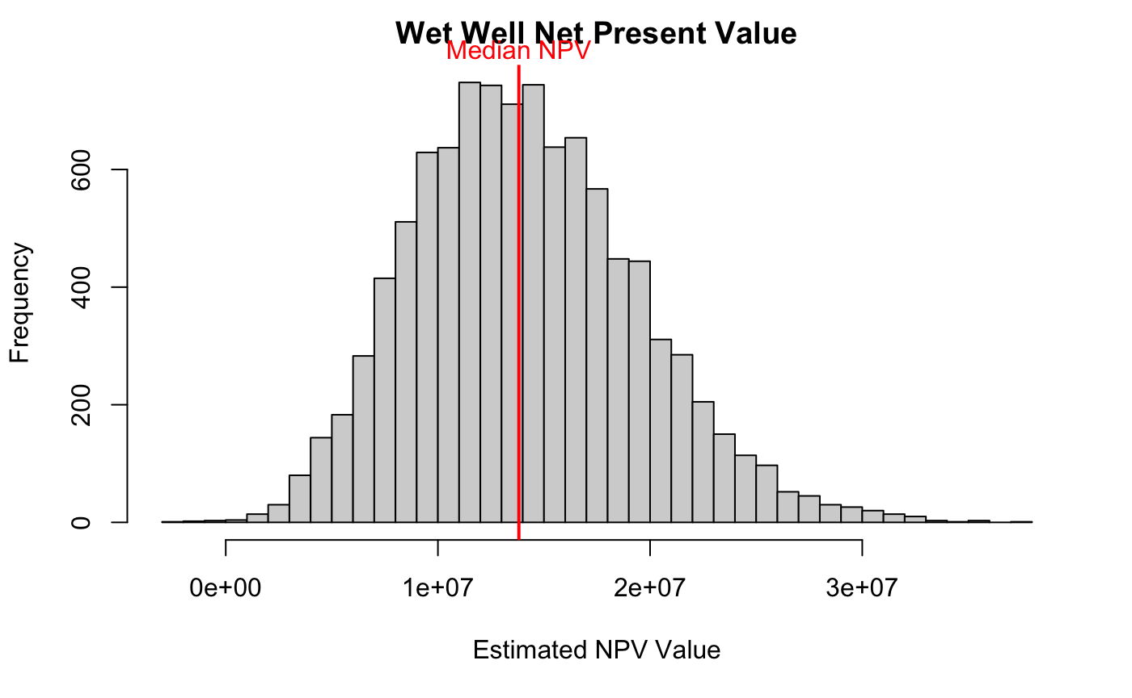

**Figure 2: 10,000 Simulated Future Values of Wet Well NPV**

**Homework Report Checklist**

The team member(s) responsible for checking each item should enter their initials in the field next to each question. All items should be addressed before submitting the assignment with the initial checklist attached.

**Sections & Structure**

**Overview**

| KK | Is the overview concise? |
| --- | --- |
| KK | Does it provide context about the business problem? <Content> |
| KK | Does it briefly address your team’s work, quantifiable results, and recommendations? <Action> |
| KK | Does it offer audience-centered reasons for recommendations? <Context> |

**Body Sections**

| KK | Does the report body include information on methods, analysis, quantifiable results, and  recommendations? |
| --- | --- |
| KK | Is content grouped into appropriate sections (methodology, analysis, results, recommendations)? |

**Conclusion**

| KK | Does the report have a conclusion? |
| --- | --- |
| KK | Does the conclusion sum up the report and emphasize relevant takeaways? |

**Structure**

| KK | Does each major section have a heading? |
| --- | --- |
| KK | Are sections, subsections, and paragraphs organized logically for easy navigation? |

# 

**Visuals**

**Introduction, Discussion, and Captions**

| DM | Is each visual introduced in the text before it appears? |
| --- | --- |
| DM | Is each visual close to where it is introduced? |
| DM | Does each visual include a title with the following information: type (table or figure), number, and a descriptive caption? |
| DM | Is each visual discussed and interpreted in the text? |
| DM | Are figures and tables numbered separately? |
| DM | Are table captions above the table? Are figure captions below the figure? |

**Visual Design**

| DM | Do figures/tables use audience-friendly labels rather than variable names? |
| --- | --- |
| DM | Are the visuals easy to interpret? |
| DM | Are the visuals appropriately sized? |
| DM | Do tables appear on one page (not split between 2 pages)? |
| DM | Are legends and axis labels included for figures? |
| DM | Are numbers in tables right aligned? |
| DM | Are the visuals designed well (ex: re-created in Word or Excel, not blurry or stretched,…)? |

**Document Design**

**Title Page Design**

| CC | Does it include a descriptive title? |
| --- | --- |
| CC | Does it state the team name, team members’ names, and the submission date? |

**Table of Contents Design**

| CC | Does it list all the major sections of the report with corresponding page numbers? |
| --- | --- |
| CC | Do the page numbers and sections in the Table of Contents match the report? |

**Document Design for Entire Report**

| CC | Is a standard typeface (Calibri, Arial, etc.) used? |
| --- | --- |
| CC | Is the size of the body text between 10-12 pt.? |
| CC | Are headings and subheadings used to organize information? |
| CC | Are distinctive text styles (bold, italic, etc.) used to distinguish between heading levels? |
| CC | Are text styles for headings used consistently (ex: all level-one headings are bold)? |
| CC | Are all paragraphs an appropriate length (fewer than 12 lines)? |
| CC | Is white space used to indicate paragraph breaks? |
| CC | Are bullet lists used for a series of items and numbered lists to show a hierarchy? |

# 

**Writing Style and Mechanics**

**Spelling and Capitalization**

| MJ | Are spelling errors located and corrected? |
| --- | --- |
| MJ | Is spelling consistent throughout (no switching between acceptable spellings)? |
| MJ | Is capitalization used appropriately (proper nouns, etc.)? |
| MJ | Is capitalization of words consistent throughout the report? |

**Grammar and Punctuation**

| MJ | Are verb tenses used appropriately? |
| --- | --- |
| MJ | Are marks of punctuation used appropriately? |
| MJ | Is subject-verb agreement used in every sentence? |
| MJ | Is the grammar checker updated and are underlined grammar issues addressed? |

**Writing Style**

| NT | Are all sentences in the report easy for your audience to understand quickly? |
| --- | --- |
| NT | Are most sentences written in active voice? |
| NT | Are idioms and vague words eliminated from the report? |
| NT | Are acronyms introduced before being used? |
| NT | Are well-written topic sentences included at the beginning of each paragraph? |
| NT | Are lists parallel? |
| NT | Is the appropriate point of view used when addressing your audience or describing team actions? |